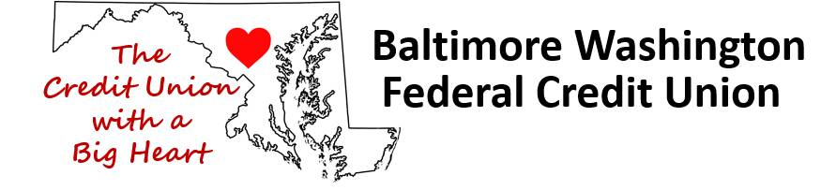 | 301 Hospital Dr  Glen Burnie MD 21061-5803  410-787-4680
*Loan Rates as of February 7, 2023
Loan Type | A.P.R. |  | Term
Vehicle / Motorcycle  New and Used |  | as low as 5.75% | for 36 months
Vehicle / Motorcycle  New and Used |  | 5.75 to 14.25% | 48 to 84 months
Signature /Personal Loans |  | As low as 9.00% | up to 60 months
CD Share Secured Loans |  | As low as 5.75% | for 12 months  other terms available
Boat and RV Loans |  | as low as 6.05% | up to 144 months
Visa Credit Cards |  | 6mo Intro- 7.39% then as low as 9.99% | revolving
Short Term Small Loans |  | up to $1,000 at 27% | up to 12 months
Stress Relief Loans |  | up to $1,200 at 12% | 12 months
A.P.R. Means Annual Percentage Rate.
Rates based on applicant's credit worthiness, terms.
New is a vehicle that has never been titled.
*Rates are subject to change.

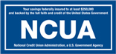  NCUA  National Credit Union Administration,  a U.S. Government Agency | 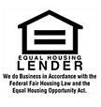
Your savings federally insured to at least $250,000 and backed by the full faith and credit of the United States Government.
© 2016 Baltimore Washington FCU
www.baltimorewashingtonfcu.org

